Remote & Multi-State COBRA Compliance Checklist
Use this checklist to ensure you're fully compliant with COBRA requirements for remote, hybrid, and multi-state teams. Each section below corresponds to a core area of compliance risk and includes action items to implement immediately.

1. Determine Jurisdiction
- Identify each employee’s work location and legal residence (not company HQ).
- Research applicable COBRA or mini-COBRA laws for each state.
- Flag employees in states with extensions (CA, NY, NJ, MA, CT, etc.).

2. Confirm Mailing Address Accuracy
- Require physical mailing address during offboarding.
- Cross-check addresses in HRIS, payroll, and COBRA admin systems.
- Avoid relying on email or digital notice alone.

3. Track Qualifying Events Accurately
- Standardize how HR logs qualifying events (termination, divorce, Medicare, etc.).
- Communicate each event to your COBRA administrator within 14 days.
- Review if voluntary hour reductions still trigger COBRA.

4. Verify Timeline Adherence & Delivery Proof
- Log the date of the qualifying event and notice delivery.
- Confirm notices are mailed within 44 days of the event.
- Retain USPS or certified mail proof of delivery.
- Keep timestamped records of employee responses or bounce-backs.

5. Coordinate with HIPAA & Marketplace Rules
- Remind employees of their option to enroll in ACA marketplace plans.
- Ensure COBRA notices explain rights clearly.
- Offer COBRA first, even if employee chooses ACA coverage later.

6. Confirm COBRA Vendor Responsibilities
- Audit your vendor's system and workflows.
- Request a COBRA filing and notification sample from past 12 months.
- Set up automated alerts for incomplete or failed notices.
- Ensure vendor supports multi-state nuances.

7. Retain Documentation for Audits
- Store copies of all COBRA notices for at least 3 years.
- Maintain logs of all sent and received communication.
- Retain proof of employee plan election, waiver, or inactivity.
---
📊 Sample COBRA Timeline Chart
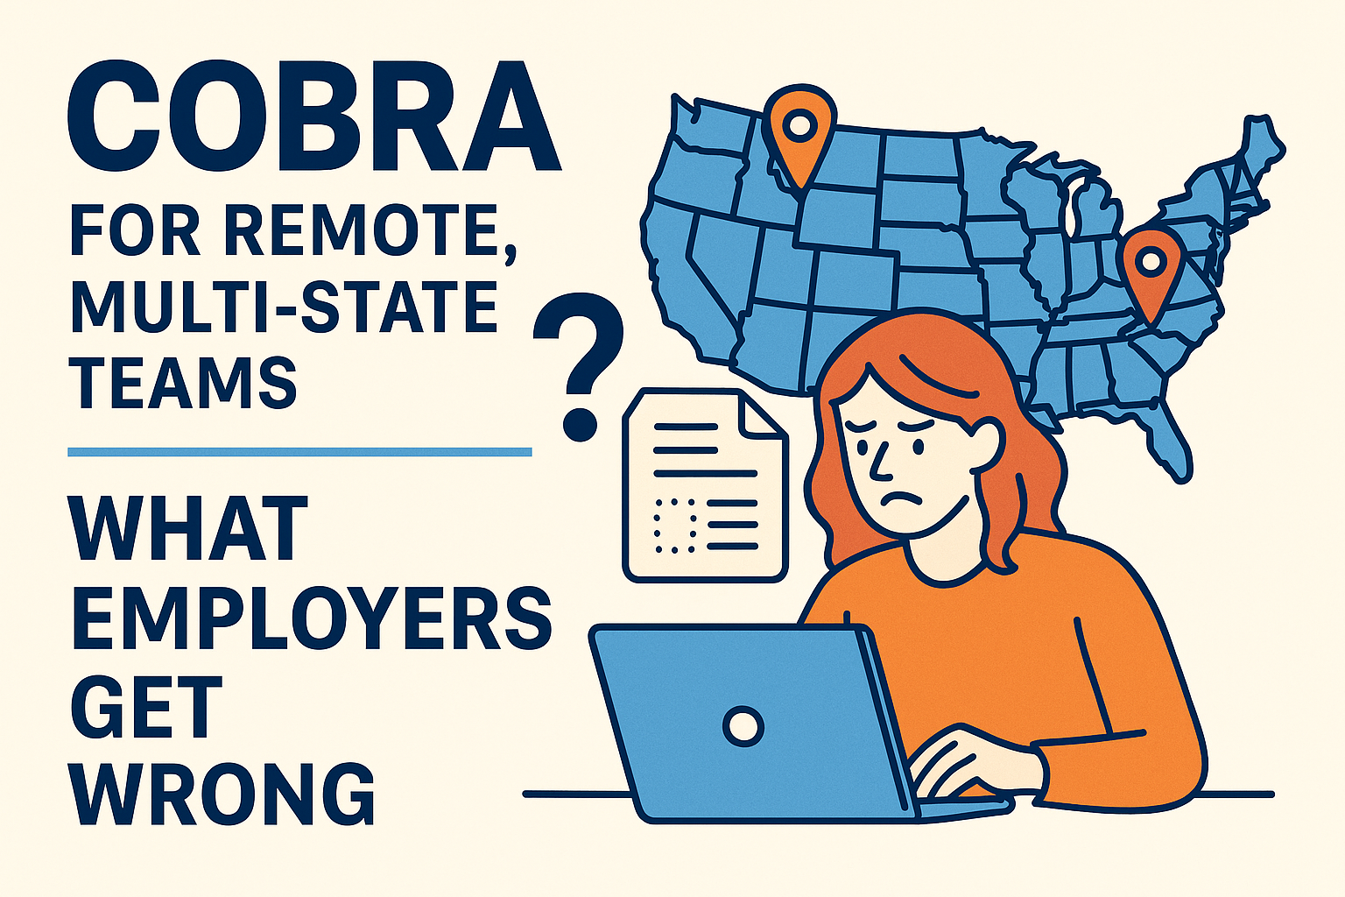
---
📋 Address Verification Flow (Checklist)
Step | Description
1 | Verify employee’s physical mailing address at time of exit.
2 | Cross-check address with HRIS, payroll, and COBRA admin.
3 | Update records immediately before notice is sent.
4 | Confirm notice delivery (via USPS or certified mail).
5 | Log all steps and timestamps for audit trail.

